*IV Curves*

The following section explains IV curves and related parameters. IV curves are a plot of current, *I*, as a function of voltage, *V*, that is useful for characterizing the performance of a solar cells. The most important parameters related to IV curves are short circuit current (*Isc*), open circuit voltage (*Voc*), and the maximum power point.

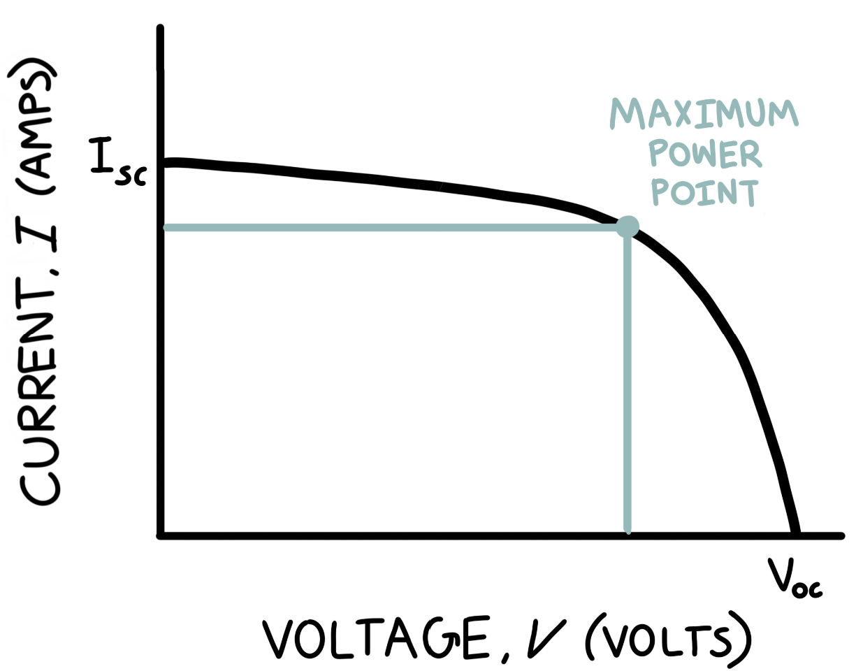

*Short Circuit Current, Isc*

Short circuit current is the current when the voltage across the solar cell is zero. This scenario is as if a wire with zero resistance is connected from the positive side of the solar cell to the negative side of the solar cell, creating a short circuit in which there is no voltage drop.

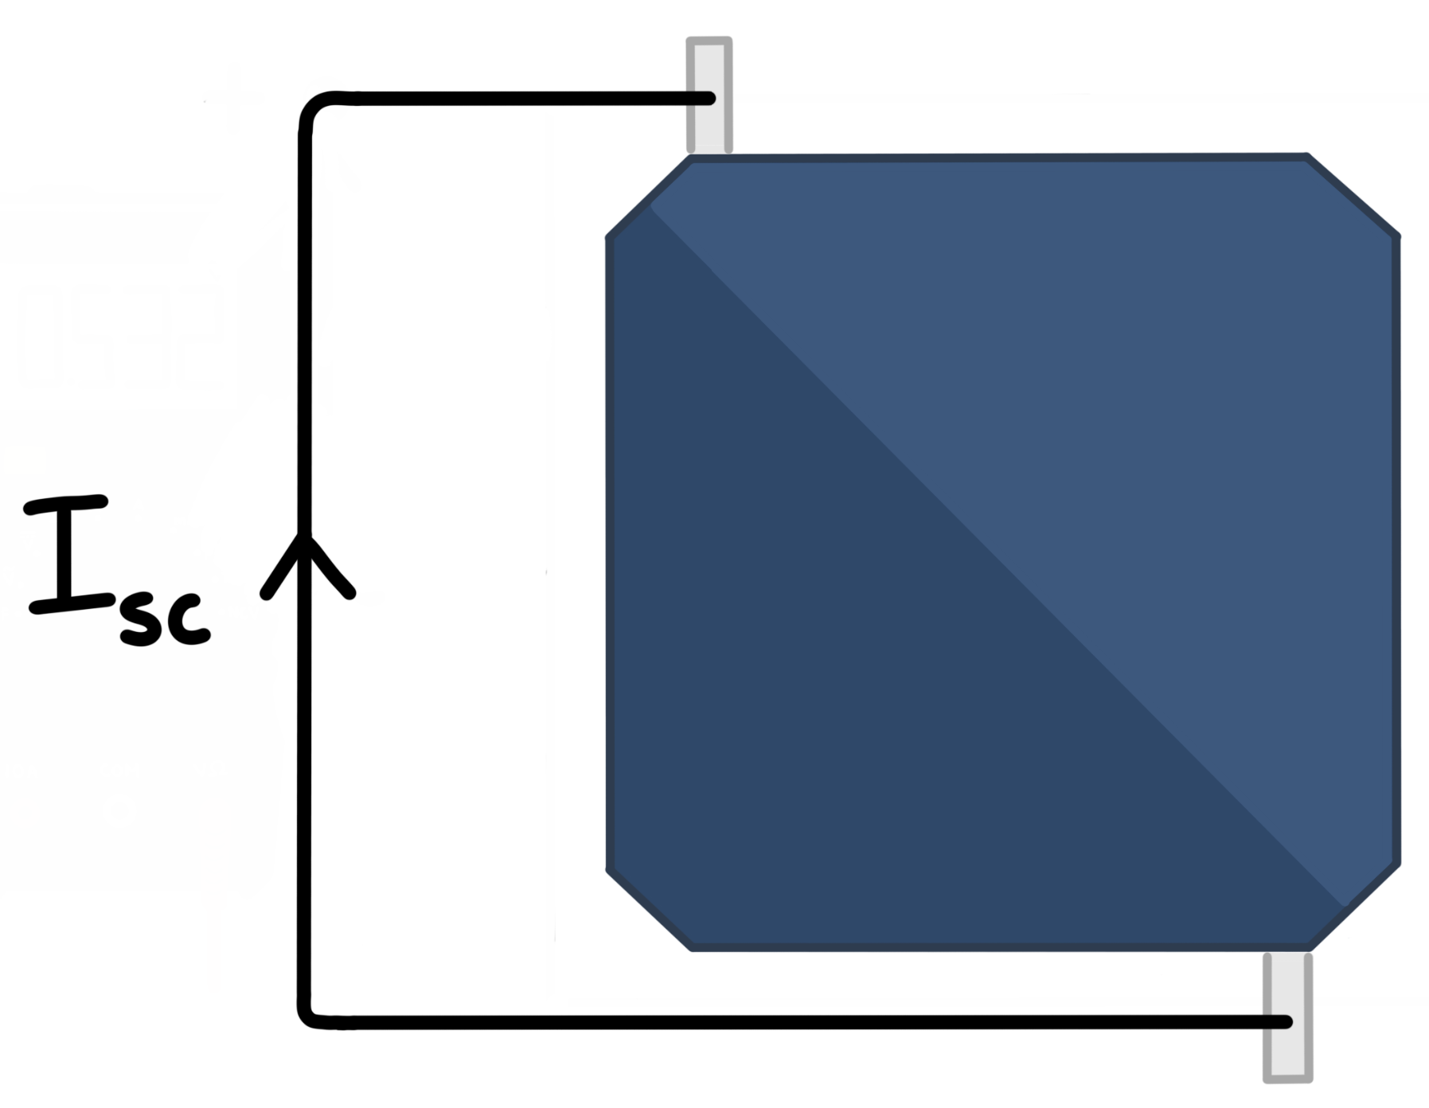

*Open Circuit Voltage, Voc*

Open circuit voltage is the voltage across the solar cell when the current is zero. This scenario is as if the solar cell is not connected to anything, creating an open circuit in which no current flows.

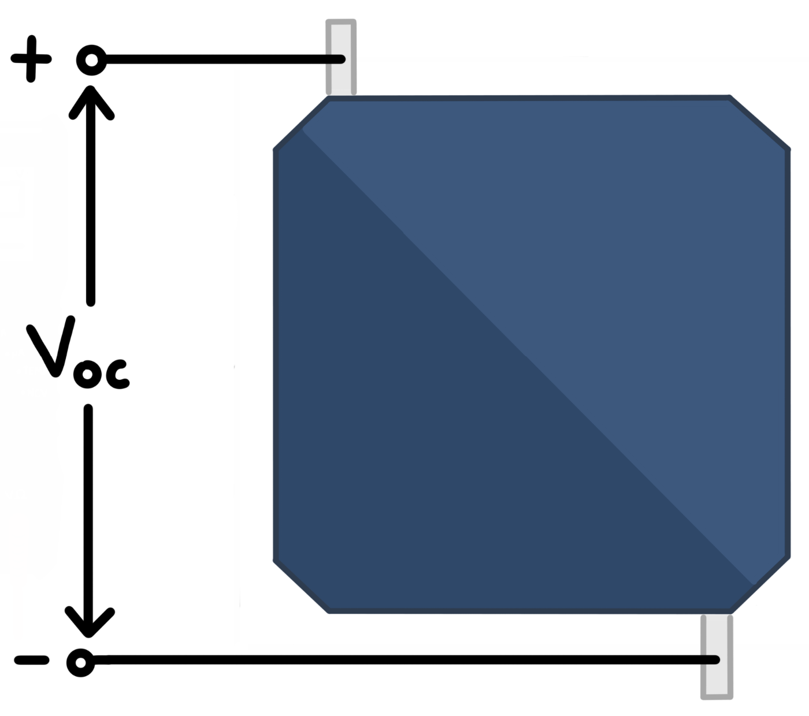

*Maximum Power Point*

From physics, power is the product of current times voltage. The maximum power point is the point on the IV curve where the product of current and voltage is maximized. This is the most desirable location on the IV curve for solar cells to operate at. Maximum power point trackers, or MPPTs, can be used to improve the power output of a solar array by helping it operate at its maximum power point under different conditions.

*Understanding IV Curves*

IV curves are generated with an instrument called an IV curve tracer. However, short circuit current and open circuit voltage can be obtained by hand with a multimeter. IV curves can be used to identify problems with underperforming solar arrays. A well-performing solar array has an IV curve with a distinct “knee” shape, after which the curve drops off with a steep slope. On a previous array, we were able to identify excess series resistance as the cause of lower than expected power output. A solar array with excess series resistance is identified by an IV curve shape without a distinct “knee” and a lower slope at greater voltages than the ideal solar array’s IV curve. This problem was solved by soldering the solar cell wires to their connecting wires.

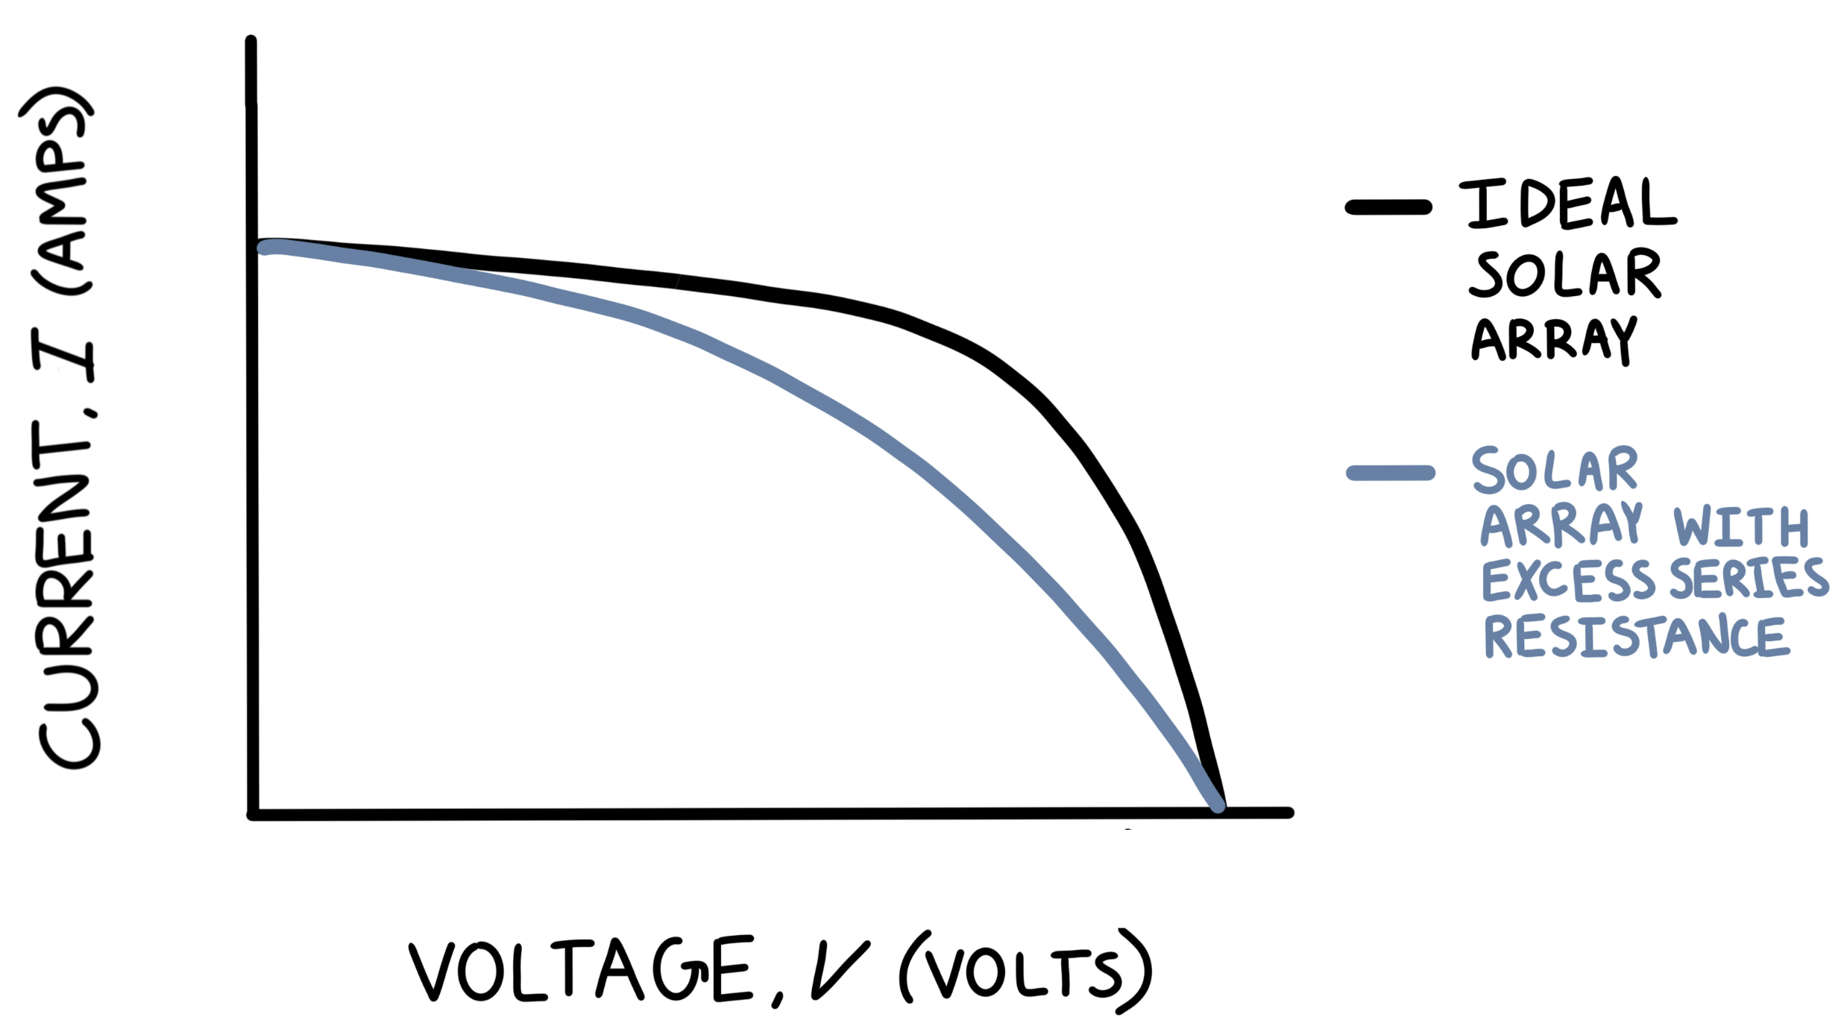

IV curves are impacted by environmental conditions. The intensity of the sunlight is one factor that changes the shape of an IV curve, as well as the values of *Isc* and *Voc*. The intensity of the sunlight reaching the solar cells is affected by the angle of the solar cells with respect to the sun and the cloud coverage. Temperature also impacts IV curve shapes. Greater temperature of the solar cells decreases their performance.

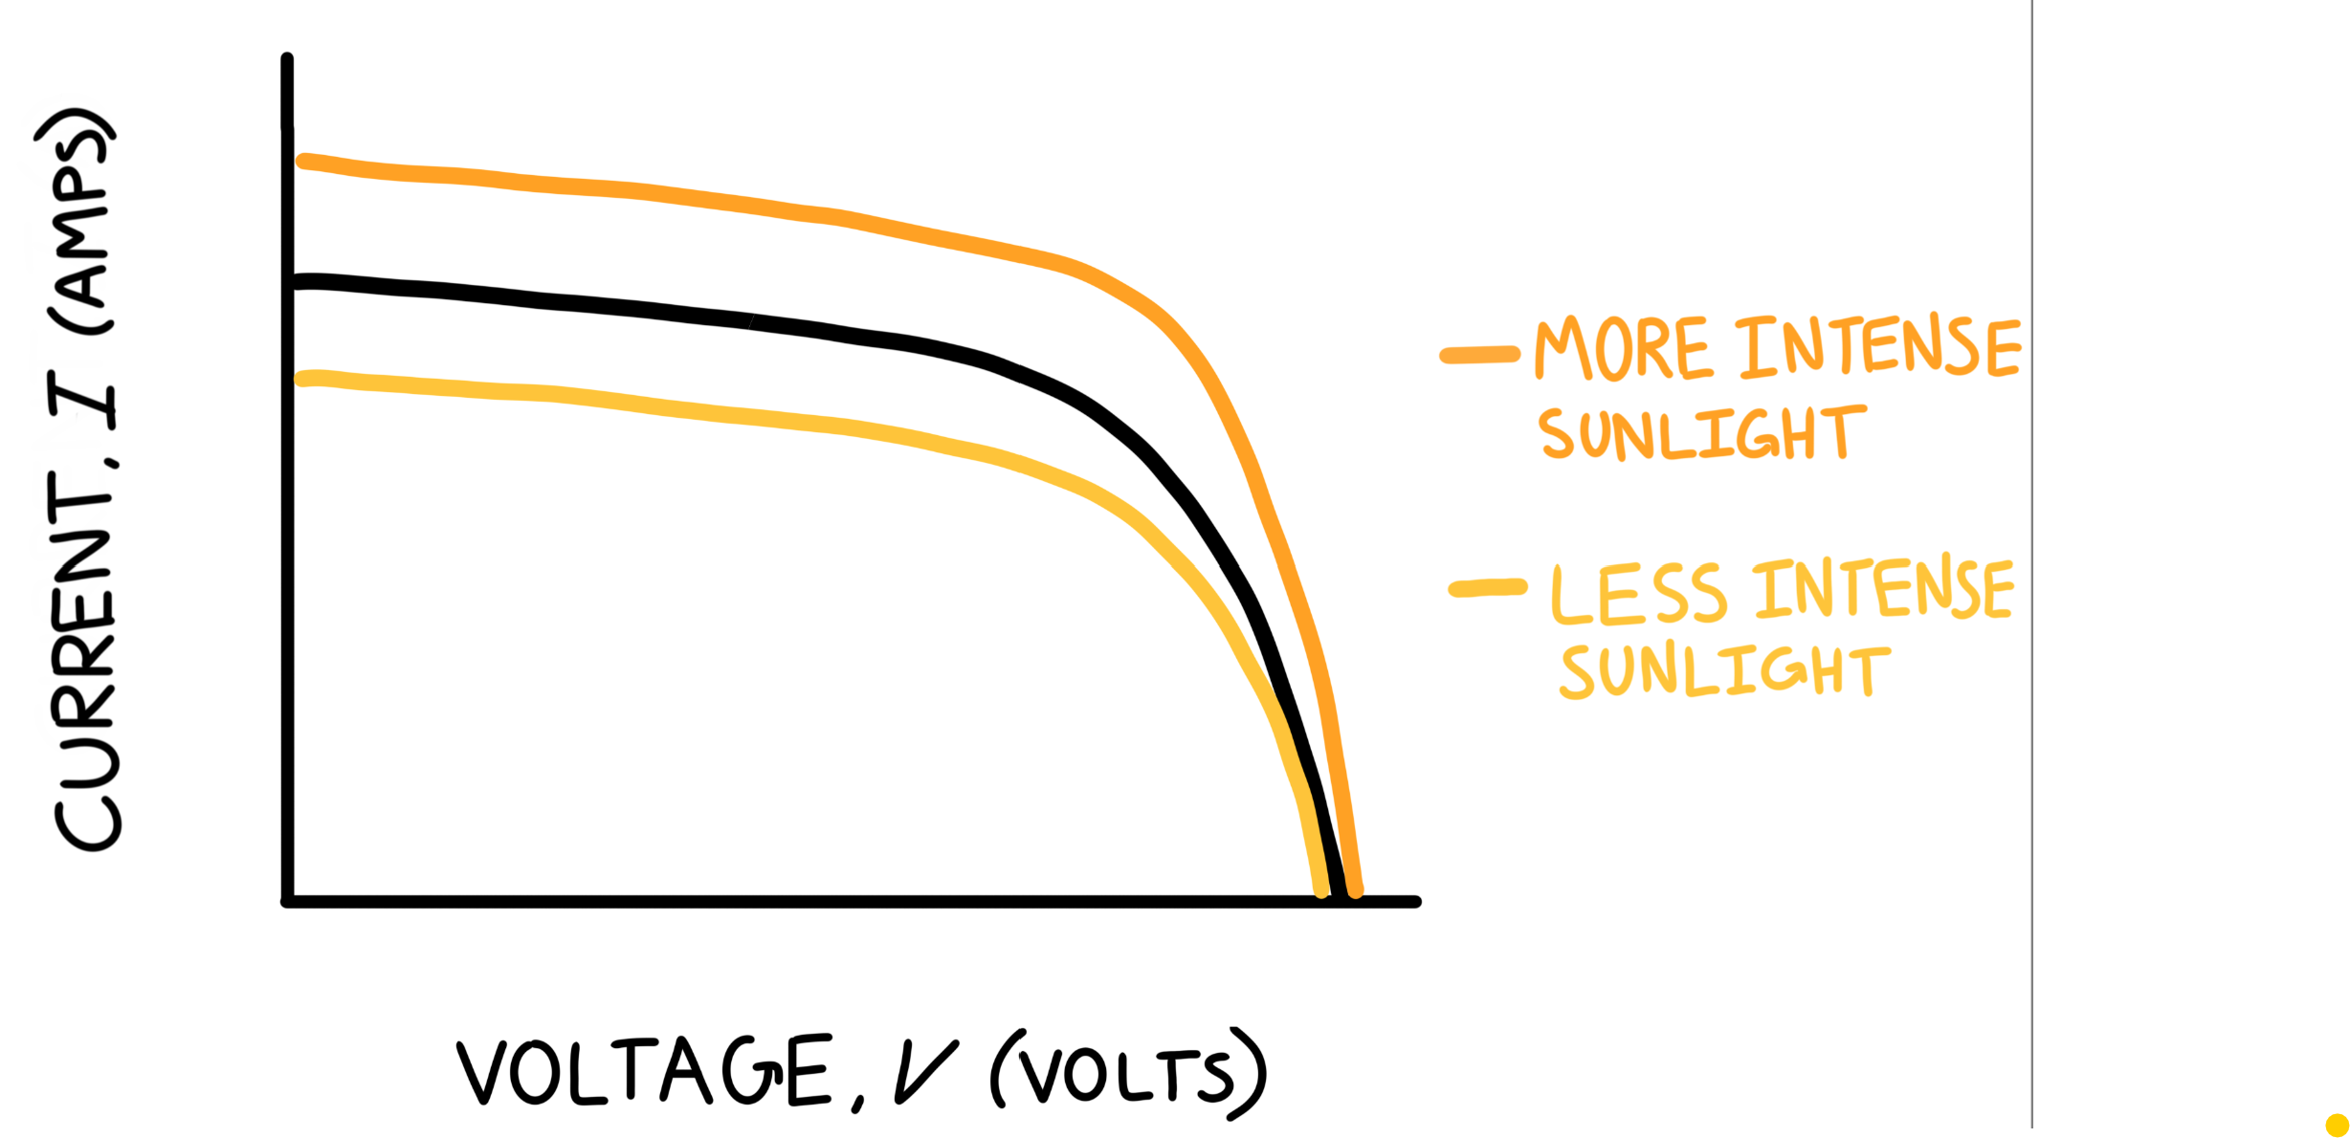

Solar cell data sheets typically present values for *Isc*, *Voc*, and the current and voltage at the maximum power point. These data sheet values are obtained at standard testing conditions, or STC, which are a temperature of 25 ○C and an irradiance of 1000 W/m2. Since it is established that IV curves are impacted by environmental conditions, data sheet values of *Isc* and *Voc* cannot be directly compared to measured values. However, if measurements of *Isc* and *Voc* in bright sunlight are reasonably close to those reported on the solar cell data sheets, it is still a good indicator of the quality of soldering and encapsulation.